**In the spirit of “Sharing is Caring” – Thank you Microsoft 365 & SharePoint Community (PnP) team!**

# HOW TO: Embed a Bing Map with info pushpins in a SPFx web part.

**NOTE:** This document assumes that you have your spfx development environment setup.   
  
If not, head over to this article for details on how to set it up:  
<https://docs.microsoft.com/en-us/sharepoint/dev/spfx/set-up-your-development-environment>

1. This web part retrieves list items containing Location specific info such as Title, Street, City, State, Postal Code, Latitude and Longitude coordinates, hours of operation, and then displays a Bing Map with pushpins and information boxes corresponding to each Location.  
     
   Here is a screenshot of the List that I used for the web part. It is a list of COVID-19 testing centers in Chicagoland. The List has GeoLocation columns – Address, Street, City, State, Postal Code, and Coordinates (Latitude and Longitude).  
     
   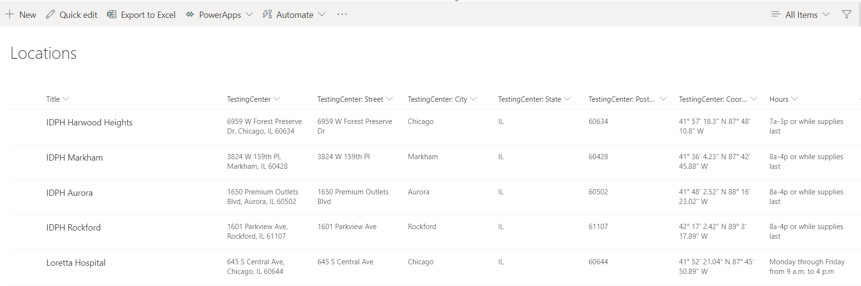
2. To use Bing Maps in your solution, you will need a Bing Maps key. You can get one at the site shown below:  
   [Getting a Bing Maps API Key](https://docs.microsoft.com/en-us/bingmaps/getting-started/bing-maps-dev-center-help/getting-a-bing-maps-key)
3. The **ReactBingmaps** component that I used in the solution can be obtained at the site listed below:  
   <https://www.npmjs.com/package/react-bingmaps-plus>
4. Add your Bing Maps key in the line shown below in the **BingMap.tsx** file in the solution.  
     
   **
5. Once you’ve setup your SharePoint list and setup the Bing Maps API Key in the solution you can test the solution locally using “gulp serve”. Make sure you update the name of the SharePoint List to match the list name in your environment in the **componentDidMount()** function in **BingMap.tsx**.  
   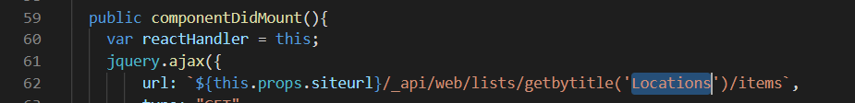
6. Add the web part to a page in your SharePoint Online site. Configure the Site Url property in the web part property pane as shown below. This is the URL of the site containing the list of Location items.  
     
   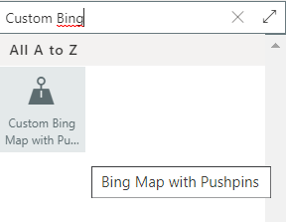  
     
   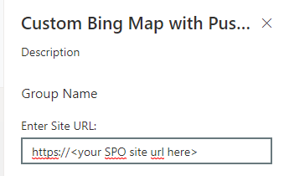
7. The web part will be displayed as follows. Clicking on the pushpins will display the info boxes in a pop up window.  
     
   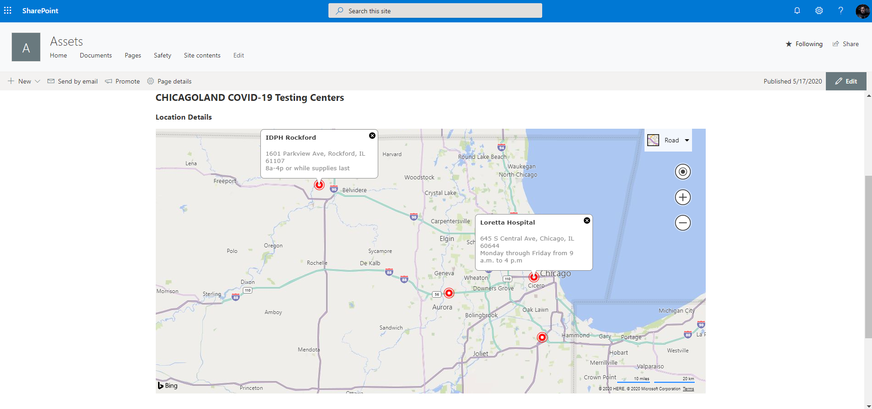  
     
   Clicking on the dropdown list at the top right of the map shows the different map views:
   * Road
   * Aerial
   * Bird’s eye
   * Streetside

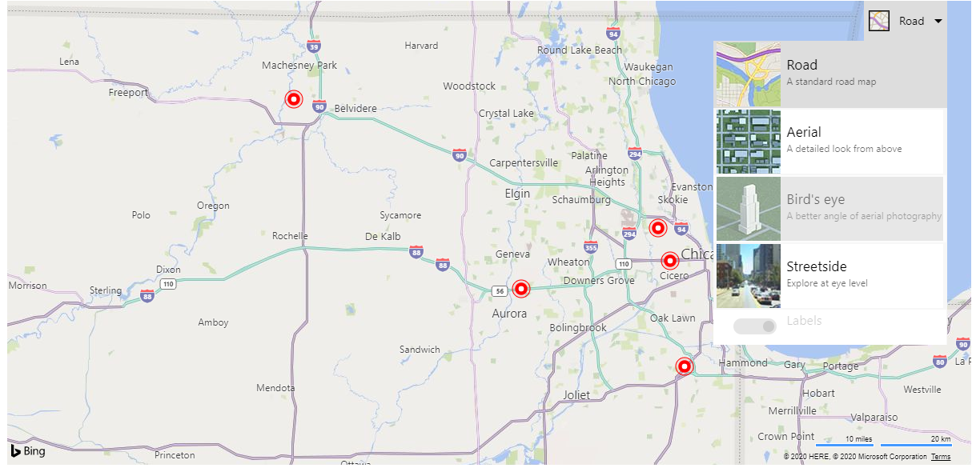

1. The styles related to the Bing Map are in the **ReactBingmaps.css** file located under this folder  
   \solutions\bingMap\node_modules\react-bingmaps-plus\lib\components\ReactBingmaps  
   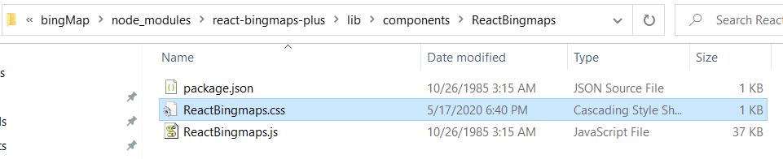  
     
   These are the current css settings:  
     
   